Types of shops.

**To speak about types of shops, you need the appropriate vocabulary.**

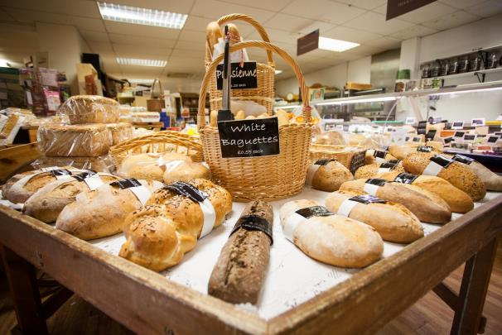

**Petrol station** - a place where you can buy petrol;

**Antique shop** - a shop where old, and often rare or beautiful objects are sold;

**Chemist‘s** - a shop where you can buy drugs, soap, beauty products, etc;

**Cash dispenser, cash machine** - a machine, usually in a wall outside a bank, from which you can take money out of your bank account using a special card;

**Flea market** - a market where you can buy old or used things cheaply;

**Cash-and-carry** - a large shop where people, usually from another business, can buy large amounts of goods cheaply and take them away immediately;

**Bakery** - a shop where you can buy bread, cakes, etc;

**Boutique** - a small shop that sells fashionable clothes;

**Off-licence, offie, liquor store, bottle shop** - a shop that sells alcoholic drink;

**Newspaper stand, newsagent’s** - a shop that sells newspapers, magazines, and things like sweets and cigarettes;

**Haberdashery** - cloth, pins, thread, etc. used for sewing, or a shop or a department of a large store that sells these;

**Garage sale** - an occasion when people sell things, often in their garage or outside their house, that they no longer want;

**Delicatessen**- a shop, or a part of a shop which sells cheeses, cooked meats, salads, etc;

**Hypermarket**- a very large shop, usually outside the centre of town;

**Trading post** - a small place, especially in the past, far from other places in which people live, where goods can be bought and sold or exchanged;

**Bucket shop** - a travel company that sells aircraft tickets at a low price;

**Pet shop** - a shop where you can buy animals that you may keep at home;

**Stationer’s**- a shop where you can buy pens, paper, and other things for writing.

**Examples:**

*New York was originally a Dutch****trading post****.*

*Will you go to the****bakery****?*

*Where is the best****pet shop****in this town?*

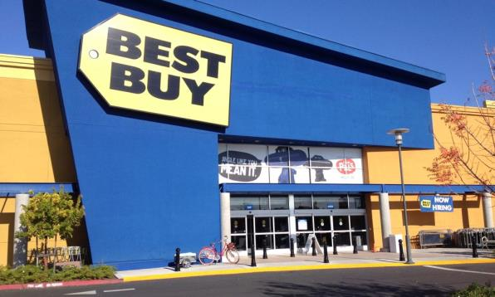

**Tearoom** - a small restaurant where drinks and small meals, such as tea and cakes, are served;

**Stall**- a small shop with an open front or a table from which goods are sold;

**Bookstall** - a table or a very small shop with an open front where books, magazines, etc. are sold;

**Bookshop** - a shop that sells books;

**Thrift shop** - a shop which sells goods given by the public, especially clothes, to make money for a particular charity;

**Confectioner’s, sweet shop** - a soft powder made from sugar that is used to make icing for cakes;

**Patisserie** - a shop that sells cakes, etc;

**Coffee shop** - a shop where different types of coffee are sold, either to drink or as beans or powder;

**Big-box store** - a very large shop that sells a large number of products, usually at low prices;

**Junk shop** - a shop that sells old furniture and other things of little value;

**Hole-in-the-wall** - cash machine;

**Duty-free** - a shop where you can buy things and bring them into a country without paying tax;

**Lingerie shop** - a shop where you can buy women's underwear;

**Toyshop** - a shop where you can buy toys ;

**Leather goods shop** - a shop where you can buy leather goods;

**Corner shop** - a small shop, especially on a corner of a road, that sells foods and other things that are often needed.

**Examples:**

*The rise of****chain retailers****led to the supremacy of****big-box stores****like Kmart, Target, and Wal-Mart.*

*Children like****toyshops****very much.*

*Women often buy fashionable things in****lingerie shops****.*

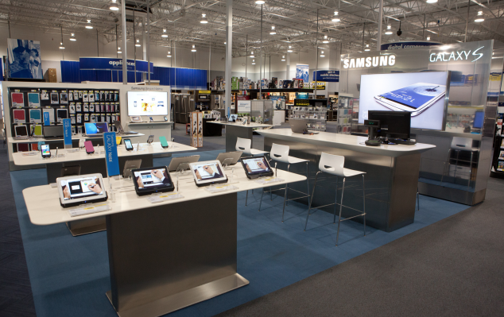

**Clothing shop** - a shop where you can buy clothes;

**Gift shop** - shop where you can buy souvenirs;

**Novelty store** - a shop where you can buy cheap, unusual things;

**Takeaway** - a meal that you buy in a restaurant but eat at home, or a shop that sells this type of meal;

**Salon**- a shop where you can have your hair cut or have your appearance improved;

**Ironmonger’s** - a shop where you can buy tools for use in homes and gardens;

**Drapery** - a shop where you can buy cloth, pins, thread, etc. used for sewing;

**Electronics shop** - a shop where you can buy electronic things for home;

**Furniture shop** - a shop where you can buy chairs, tables, sofas and other things;

**Dairy** - a shop where you can buy cheese, milk, cream;

**Photo booth** - a place where you can buy things for photography and print your photos;

**Record shop** - a music shop;

**Butcher’s** - a shop that prepares and sells meat.

**Examples:**

*We often go to****takeaway****. Their food is wonderful.*

*There is a****drapery****on the city centre.*

*Have you visited a****salon****?*

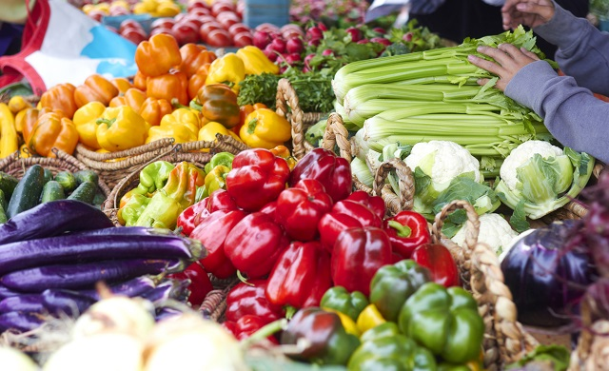

**Concession** - a reduction in the price of a ticket for a particular group of people such as students, people without a job, or old people;

**Minimarket** - a store that sells food and sometimes other goods, but is not as big as a supermarket;

**Shoe shop** - a shop where you can buy boots, sandals, trainers and other types of shoes;

**Greengrocer’s**- a shop where you can buy fruit and vegetables;

**Optician’s** - a shop where you can have your eyes tested and have your glasses made;

**Gun shop** - a shop where you can buy pistols and other types of guns;

**Megastore** - a very large shop;

**Hairdresser’s** - the place where you go to have your hair washed, cut, coloured, etc;

**Barbershop**- a shop where a barber works;

**Perfume shop** - a shop where you can buy liquids with a pleasant smell that women or men put on their skin;

**Post office** - a place where you can buy stamps and send letters and parcels;

**Fishmonger’s**- a shop that sells fish;

**Market** - a place where people go to buy or sell things, often outside;

**Garden centre** - a place that sells things for gardens such as plants and tools;

**Beauty salon** - a place where your hair, face, and body can be given special treatments to improve their appearance;

**Examples:**

*I'll stop at the****fishmonger's****on my way home from work.*

*Mary Sally is the name of the most famous****beauty salon****.*

*I buy products in the****market.***

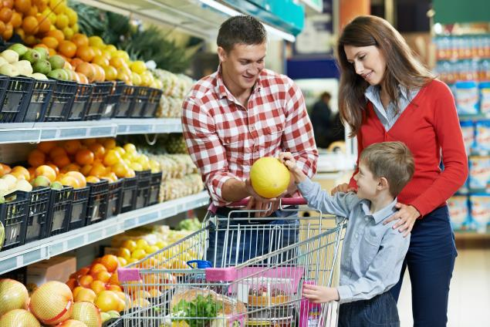

**Service centre** - a store or other place where you can have products, equipment, or vehicles checked and repaired and where you can buy parts;

**Chain store** - one of a group of similar shops owned by the same company;

**Gift shop** - a shop that sells goods that are suitable for giving as presents;

**Supermarket**- a large shop that sells food, drink, products for the home, etc;

**Tobacconist’s** - a shop where you can buy cigars, cigarettes and other tobacco things;

**Pay phone** - a telephone in a public place that you pay to use;

**Shopping centre, mall** - a place where a lot of shops have been built close together;

**Travel agency** - a company or shop that makes travel arrangements for people;

**Department store** - a large shop divided into several different parts which sell different types of things;

**General store** - a shop that sells a wide range of products, often the only shop in a village;

**Dry cleaner’s, the cleaners, launderette** - a shop where you can have your clothes cleaned this way;

**Hardware shop** - a shop where you can buy tools and strong equipment, such as those used in the home or garden;

**Florist’s** - a shop that sells flowers;

**Jewellery shop, jeweller’s** - a shop where you can buy objects made from gold, silver, and valuable stones that you wear for decoration

**Examples:**

*Contact a Computer World****service center****for repair.*

*Mary likes visiting****florist’s.****She is fond of flowers.*

*Mike will go to Spain. Last week she went to the****travel agency****.*

Sales

**To speak about sales, you need the appropriate vocabulary.**



**After-sales service** - service provided after a customer has paid for and received a product or service;

**Buyer** - someone who buys something;

**Sales**- the number of items sold;

**Close a deal** - to make a successful business arrangement with someone;

**Cold call** - the activity of calling or visiting a possible customer to try to sell them something without being asked by the customer to do so;

**Customer** - a person or organization that buys goods or services from a shop or business;

**Deal**- an arrangement or an agreement, especially in business;

**Discount** - a reduction in price;

**Warranty** - a written promise made by a company to change or repair one of its products if it has a fault;

**In bulk** - in large amounts;

**Lead**- to show someone where to go, usually by taking them to a place or by going in front of them;

**Objection** - when someone says that they do not like or approve of something or someone;

**Prospect**- the idea of something that will happen in the future;

**Sales representative** - someone who travels to different places trying to persuade people to buy their company's products or services;

**Retail**- when products are sold to customers from shops;

**Wholesale** - relating to products which are sold in large amounts, usually at a cheaper price.

**Examples:**

*We closed a deal with a major****supermarket****.*

*Mrs Wilson is one of our regular****customers.***

*This shop has****wholesale****prices.*

Shopping.

**To speak about shopping, you need the appropriate vocabulary. Part 1**

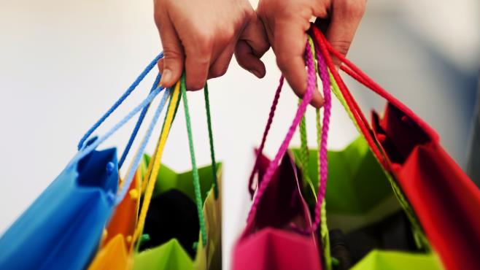

**To do the shopping** - buy things from shops;

**To go shopping** - go to the shops;

**Window shopping** - the activity of spending time looking at the goods on sale in shop windows without intending to buy any of them;

**Choice** - when you can choose between two or more things;

**Cheap** - not expensive, or costing less than usual;

**Expensive** - costing a lot of money;

**Long** - continuing for a large amount of time;

**Short** - having a small distance from one end to the other;

**Tight** - fitting your body very closely;

**Big** - large in size or amount;

**Small** - little in size or amount;

**Wide** - measuring a long distance or longer than usual from one side to the other;

**Loose** - large and not fitting tightly;

**Cash desk** - the place in a shop where you pay for the things that you buy;

**Cashier** - someone whose job is to receive and pay out money in a shop, bank, etc.

**Examples:**

*I got a****cheap****flight to Spain at the last minute.*

*It's too****expensive****to go out every night.*

*She is wearing a****tight****skirt.*

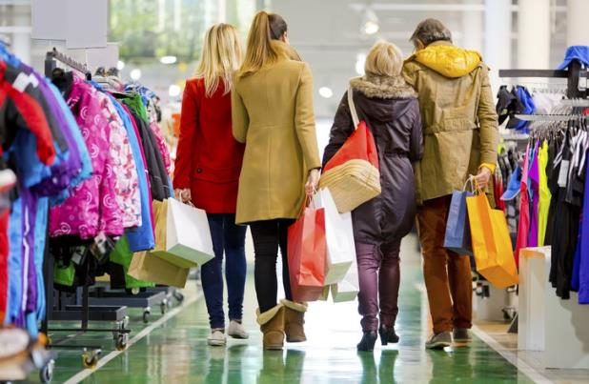

**Quality** - how good or bad something is;

**Odds and ends** - a group of small objects of different types which are not valuable or important;

**Fashion** - the most popular style of clothes, appearance, or behaviour at a particular time;

**Vogue** - if there is a vogue for something, it is very fashionable;

**Section** - one of the parts that something is divided into;

**To pay** - to give money to someone because you are buying something from them, or because you owe them money;

**To fit** - to be the right shape or size for someone or something;

**To suit** - to be exactly right or suitable for someone;

**To match** - if two things match, they are the same colour or type;

**To show** - to let someone look at something;

**Purchase** - to buy something;

**Counter** - to prevent something or reduce the bad effect that it has;

**To try** - to do, test, taste, etc something to discover if it works or if you like it.

**Examples:**

*Flat shoes are in****vogue****(= fashionable) this spring.*

*These trousers don't****fit****any more.*

*I can't find anything to****match****my green shirt.*

*Your socks don't****match.***

*Tickets must be****purchased****two weeks in advance.*

Shops. People and things

**Study the vocabulary about people and things in shops.**

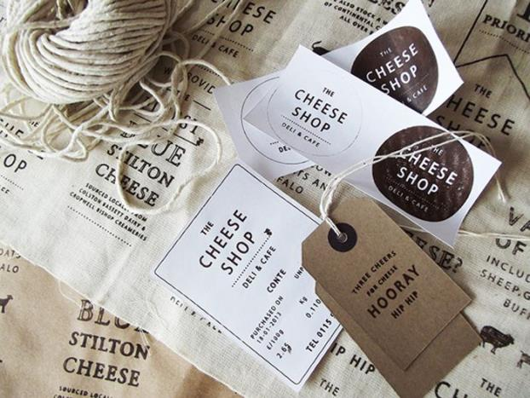

**To sell** - to give something to someone who gives you money for it;

**Salesman, shop assistant** - a man whose job is selling things;

**Saleswoman, shop-assistant** - a woman whose job is selling things;

**Size**- one of the different measurements in which things, for example clothes, food containers, etc are made;

**Out of season** - not fashionable;

**To cost** - if something costs a particular amount of money, you have to pay that in order to buy or do it;

**Style** - a way of designing hair, clothes, furniture, etc;

**Price**- the amount of money that you pay to buy something;

**Price tag** - a piece of paper attached to a product that shows the amount a product costs;

**Label** - a small piece of paper or other material which gives information about the thing it is fixed to.

**Examples:**

*He****sold****his guitar for £50.*

*She's had her hair cut in a really nice****style****.*

*There should be washing instructions on the****label.***

Go shopping. Useful phrases

**Study some useful phrases that you can use when you go shopping.**



**Are you just looking?** = do you want to look alone?

**To have a sale** = a store will have many things at a discount (The store is having a sale.)

**To be on sale** = one or more items at a discount (This shirt is on sale.)

**Hanger** = holds the clothes (a picture of it is on the left)

**Rack**= a metal (or other kind) bar that holds clothes. You put your clothes on a hanger and then put the hanger on a rack.

**Fitting room** = the place where you try on clothes

**Max out a credit card** = (this is slang) It means you have reached your limit. If you cannot spend more money on your credit card, you have maxed it out.

**How would you like to pay?** = do you want to pay with cash, a credit card, or a check?

**How does it fit?** = is it a good size for you?

**I will take it** = I'll buy it

**Who should I make the check out to?** = what name should I write on the check?

**Tax**= the extra money a store charges. It goes to the government.

**I.D.** = identification (card)

Shopping habits

**To speak about shopping habits, you need the appropriate vocabulary.**



**Indoors** - into or inside a building;

**Worry**- to think about problems or unpleasant things that might happen in a way that makes you feel anxious;

**Provide** - to supply something to someone;

**Entertainment**- shows, films, television, or other performances or activities that entertain people;

**Child-care facilities** - playrooms for children;

**Available** - if something is available, you can use it or get it;

**Downtown** - in or to the central part or main business area of a city;

**Pedestrianize** - to make an area into one where vehicles are not allowed to go;

**Outlet**- a shop that sells one type of product or the products of one company;

**Bargain** - something that is sold for less than its usual price or its real value;

**Merchandise** - goods that are traded, or sold in shops;

**Advertise**- to tell people about a product or service, for example in newspapers or on television, in order to persuade them to buy it;

**Charge** - the amount of money that you have to pay for something, especially for an activity or a service;

**Debt**- an amount of money that you owe someone;

**Accept**- to agree to take something that is offered to you.

**Examples:**

*It's a new scheme to****provide****schools with free computers.*

*There is****live entertainment****in the bar every night.*

*We stock a broad range of****merchandise.***

*She's working in a bar to try to pay off her****debts.***